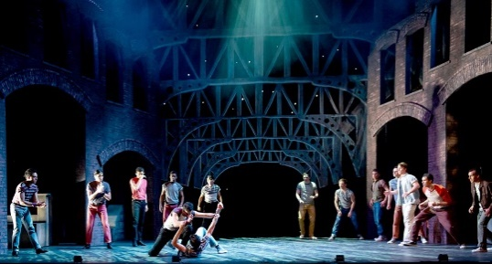  West Side Story | Heidi Hoffer  Scenographer | Production Designer  405-564-4946 (m)  http://hofferdesign.weebly.com/  http://heidihoffer.daportfolio.com/  https://www.imdb.com/name/nm8722492/  heidihoffer@gmail.com

Profile Summary: Scenographer, Production Designer, and creative with international experience in many related areas. Worked with teams of designers, production managers and technical directors to see projects from ideation to completion.
Current Work Summary
- Former Professor of Production Design at Savannah College of Art and Design
- Film: Production Design (Bob & Dale), Scenic, Consultant and / or PA for several films (I Can Only Imagine, American Gods https://www.imdb.com/name/nm8722492/
- Scene Designer: Utah Festival Opera, PCPA Theaterfest, Creede Rep Theatre, and others in USA and International
- USAA #829 Scenic Artist
- Fulbright
  - Specialist 2017-2018 in Islamabad, Pakistan
  - Fulbright Roster Candidate 2016-2022
  - Fulbright Scholar: South Africa, 2010-2011
- General Editor of TD&T (Theatre Design and Technology) journal 2004 - 2018, (peer reviewed)
- Professor Emeritus of Theatre, Past Director of Design and Technology at Oklahoma State University
- Administrator of the TheatreArtists© Gallery on the DeviantArt© website
- Language elementary Mandarin and elementary French

Education

Master of Fine Arts in Scene Design. Northwestern University, Evanston, Illinois
Master of Arts in Theatre Design and Technology. Northern Illinois University, DeKalb, Illinois
Bachelor of Arts in Theatre Arts. Northern Illinois University, DeKalb, Illinois
Company Skills:
Concept Creation-Ideation,
Collaboration, Project Management,
Supervision, Leadership,
Problem Solving, Delegating,
Design Presentations,
Budgets, Purchasing,
Remote Course & Skills Delivery,
OSHA Standards, Research,
International Work, Diplomacy

Artistic Skills:
design elements; painting;
site surveys; “Napkin-CAD”;
model building; props construction;
materials selection; color mixing; graphics layout; storyboarding; costume design; furniture restoration;
history of art, décor, and costume;
architecture and furniture history;
trompe l’oeil; figure drawing;
orchestral and ensemble music.
Computer | Program Skills:

AutoCAD 2D & 3D
Photoshop & Cintiq & Wacom
Illustrator & 3D Printing
Microsoft Office Suite
PowerPoint
EOS lighting desks, moving lights,
Q-Lab, Projection Design
Photography – SLR and digital

